John Clark Sherman Military

John Clark Sherman, born on Echtinaw Island, Coldwater Lake, Michigan to Clifford and Lucy Pearl Echtinaw Sherman, enlisted with the U.S. Army on October 27, 1942. Serving as Technician Fifth Grade, 1125 Armored Field Artillery Battalion, John was first assigned to Africa and Corsica.
From January through September 1944 he was in combat in the Campaign of Rome-Arno, Italy. The German Gustav line halted operations of the campaign for the winter.
December 1944 the 10th Mountain Army Division arrived in Italy to which his battalion was attached. Fighting in some of the roughest terrain of Italy, the 10th Mountain Division was in the campaigns and battles of North Apennines and Po Valley. The Po Valley campaign resulted in the German surrender of Italy on May 2, 1945. After the surrender the 10th Mountain Division went on security duty receiving the surrender of various German units.
John was awarded the Bronze Star Medal for bravery in combat during the Po Valley Campaign on April 19, 1945, near Monte Pastore, Italy. The citation reads in part, “The splendid actions displayed by Technician Fifth Grade Sherman at this critical time prevented probable injury or loss of life to many. Such noteworthy achievements justly require the highest praise and commendation.” He passed away May 23, 1951 from head injuries resulting from an unfortunate motorcycle accident near Coldwater.
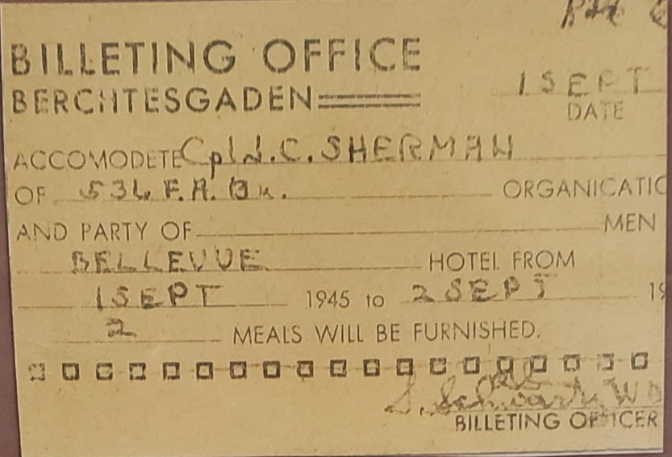
Housing authorization for one night’s stay at Bellevue Hotel, Berchtesgaden (Eagles Nest)

